**21L-7512 ABDULLAH DAR BSCS-5G-1**

**Computer Networks**

**Lab no 8**

**Lab Question no 1**

**Question no 1: What is the IP address and TCP port number used by the client computer**

**(source) that is transferring the file to gaia.cs.umass.edu?**

**Solution:**

IP Address: Source: 192.168.1.102 (192.168.1.102)

Port Number: Source Port: 1161 (1161)

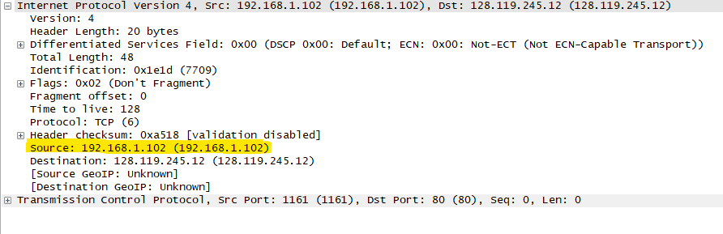

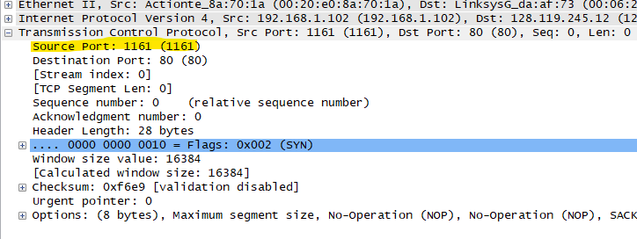

**Question no 2: What is the IP address of gaia.cs.umass.edu? On what port number is it**

**sending and receiving TCP segments for this connection?**

**Solution:**

IP Address: Destination: 128.119.245.12 (128.119.245.12)

Port Number: Destination Port: 80 (80)

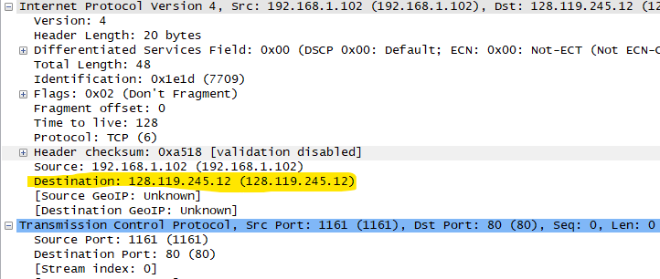

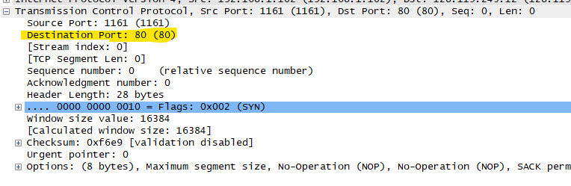

**Question no 3: What is the sequence number of the TCP SYN segment that is used to initiate**

**the TCP connection between the client computer and gaia.cs.umass.edu? What is in the**

**segment that identifies the segment as a SYN segment?**

**Solution:**

Sequence Number: Sequence number: 0 (relative sequence number)

Segment: .... .... ..1. = Syn: Set

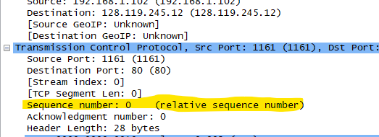

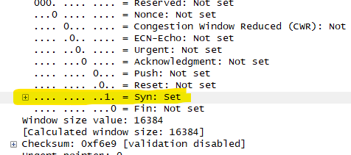

**Question no 4: What is the sequence number of the SYNACK segment sent by**

**gaia.cs.umass.edu to the client computer in reply to the SYN? What is the value of the**

**Acknowledgement field in the SYNACK segment? What is it in the segment that**

**identifies the segment as a SYNACK segment?**

**Solution:**

Sequence Number: Sequence number: 0 (relative sequence number)

Acknowledgement field: .... ...1 .... = Acknowledgment: Set

Segment: .... .... ..1. = Syn: Set

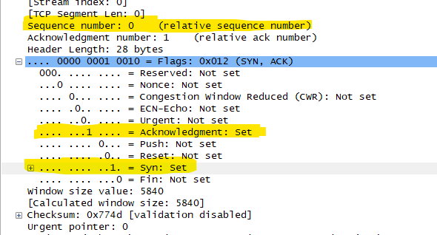

**Question no 5: In packet 9, Ack = 2026 and Seq = 1. Explain these values?**

**Solution:**

Acknowledgement Number: Acknowledgment number: 2026 (relative ack number)

Sequence Number: Sequence number: 1 (relative sequence number)

Explanation: This tells us that ACK for the packet is 1 and next Sequence number will be 2026. We also get to know the number of bits received by subtracting it 2026 – 1 = 2025 bits (as received).

**Question no 6: In packet 16, Ack = 7866 and Seq = 1. Explain these values?**

**Solution:**

Acknowledgement Number: Acknowledgment number: 7866 (relative ack number)

Sequence Number: Sequence number: 1 (relative sequence number)

Explanation: This tells us that ACK for the packet is 1 and next Sequence number will be 7866. We also get to know the number of bits received by subtracting it 7866 – 1 = 7865 bits (as received).

**Question no 7: Why Wireshark uses relative sequence and ack?**

**Solution:**

WireShark groups TCP sessions and assigns them relative sequence (and acknowledgment) numbers which start from 0 (and incrementing by 1 as it seems, for each subsequent packet) so the user can identify the sequence of events.

**Lab Question no 2**

**Question no 1: Select the first DNS packet in the trace. Determine, how many fields there**

**are in the UDP header.**

**Solution:**

There are 4 fields in UDP header as

1. Source Port
2. Destination Port
3. Length
4. Check Sum

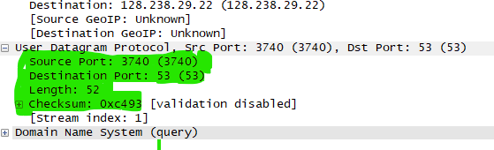

**Question no 2: From the packet content field (click on any header and observe the display in**

**the Packet Bytes Window), determine the length (in bytes) of each of the UDP header**

**fields.**

**Solution: 2 bytes each field of header.**

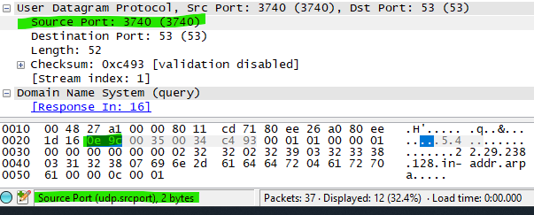

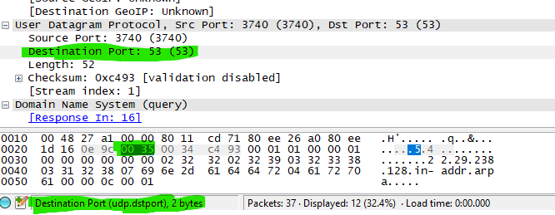

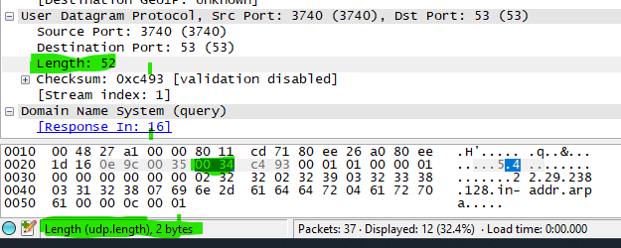

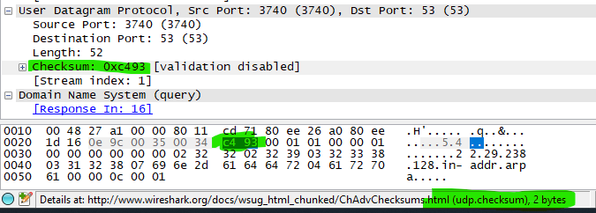

**Question no 3: The value in the Length field is the length of what? Verify your claim using**

**the selected packet.**

**Solution:**

The value In the length field is the length of data of the header fields and the data/ content associated with that data.

Here in the case 8 bytes is header fields and data in it is of 44 bytes.

Summing up 8 + 44 = 52 bytes as shown in length of header.

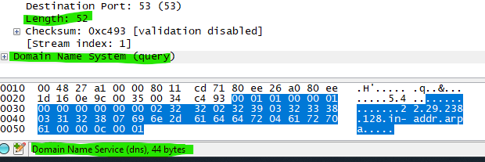

**Question no 4: What is the port number to query the DNS Server?**

**Solution:** DNS Port number is: Destination Port: 53 (53)

